# **C:\Users\Anes\Pictures\Saved Pictures\burchLOGO.jpg**

# Faculty of Engineering and Natural Sciences

# Department of IT

PROJECT PAPER

# **TWITTER DATA ANALYSIS USING NLP**

Supervisor

Prof. Dr. Dzelila Mehanovic

SARAJEVO

December 10, 2023

Mirsad Hadzic & Faris Delic

**SUMMARY**

The purpose of this research is to perform sentiment analysis on Twitter data using Natural Language Processing (NLP) techniques, particularly leveraging the NLTK library in Python within a Jupyter notebook environment. The study aims to explore sentiment classification methods, evaluating the emotional tone of tweets and categorizing them as neutral, positive, or negative sentiments, utilizing NLTK's SentimentIntensityAnalyzer.

The sample consists of Twitter data with columns like 'Tweet' and 'Sentiment' sourced from a CSV file. The methodology involves tokenizing and processing the text, grading sentiment, counting occurrences of the hashtag #fifa, and analyzing word frequencies. The research extends its analysis by employing wordclouds to visually represent the most common words and their prevalence in the dataset.

Furthermore, the study investigates the impact of removing stopwords and explores the list of eliminated stopwords. The expected results include gaining insights into prevalent sentiments on Twitter regarding a specified topic, frequency of the hashtag #fifa, and a comprehensive understanding of word usage, visually depicted through wordclouds.

Possible limitations include inherent subjectivity in sentiment analysis, potential variations in language use, reliance on hashtag frequency as an indicator of topic prevalence, and the effectiveness of stopwords removal, which may be context-dependent. The addition of wordcloud analysis enhances the visual representation of the most frequent words, providing a holistic perspective on the dataset.

**INTRODUCTION**

This research dives into Twitter's world, specifically tweets with #fifa, using NLTK in Python to decode sentiments. The main goal is to create word clouds, spotlighting the trendiest words and those linked to #fifa. We're also testing how well our sentiment guesses match real sentiments. Plus, we're poking at word variations using Lancaster and Porter stemmers.

Why word clouds? Well, they're like visual summaries, making the data fun and digestible. By doing this, we hope to uncover the vibe around #fifa on Twitter and see how sentiment analysis and word variations play out in the social media chatter. It's all about decoding the Twitter talk on #fifa in a snappy, visual, and insightful way! 🌐⚽✨

**THEORETICAL BACKGROUND**

Natural Language Processing (NLP): This project relies on Natural Language Processing (NLP), a field blending language studies with technology. We use tools like the Natural Language Toolkit (NLTK) to help computers understand and work with human language. [1]

Sentiment Analysis: Sentiment Analysis is like a digital mood detector. We're inspired by the work of Pang and Lee, who explored ways to teach computers to understand feelings in text. Another source by Stefano Loria helps us understand the challenges in this task. as mentioned in [2] – [3]

WordCloud Visualization: To make things more visual, we use something called WordClouds. These show us the most important words in a bunch of text. We get this from the WordCloud library. [4]

In a nutshell, we're combining these ideas to understand how people express their feelings on Twitter. The tools we're using are like language detectives helping computers join in on the conversation.

**LITERATURE REVIEW**

#### 1. **Introduction to Sentiment Analysis**

* Briefly introduce Sentiment Analysis (SA) as a crucial aspect of Natural Language Processing (NLP).
* Discuss the evolution from manual sentiment analysis to automated methods.

#### 2. **Historical Context**

* Explore early works, such as the development of sentiment lexicons, like the General Inquirer. [5]
* Discuss the transition to machine learning approaches in sentiment analysis.

#### 3. **Foundational Research**

* Summarize influential studies in the early 2000s, like the work of Pang and Lee[2], which laid the groundwork for machine learning-based sentiment analysis.

#### 4. **Advancements in NLP Techniques**

* Detail the impact of advancements in NLP techniques, such as the introduction of deep learning models like recurrent neural networks (RNNs) and transformers. [3]

#### 5. **Challenges and Innovations**

* Highlight challenges in sentiment analysis, such as handling sarcasm and context, and discuss innovative solutions proposed in recent research. [6]

#### 6. **Recent Trends**

* Provide an overview of recent trends in sentiment analysis, including the integration of domain-specific knowledge and the use of pre-trained language models like BERT and GPT. mentioned in [7][13]

#### 7. **Application Areas**

* Explore how sentiment analysis has diversified into various application areas, including social media analytics, customer feedback analysis, and political sentiment tracking. [8]

#### 8. **Ethical Considerations**

* Discuss ethical considerations in sentiment analysis, addressing issues like bias and privacy, and highlight recent research aiming to address these concerns. [9]

#### 9. **Word Cloud and Regex Techniques**

* Introduce the relevance of word clouds in visualizing word frequencies and cite practical guides for creating word clouds using NLTK in Python. as mentioned in [10]-[11]
* Explore the NLTK Regex module for chunking and regex-based information extraction. [12]

**Hypotheses (Research Questions) and Research Mode**

1. *Research Questions:*
   * RQ1: How accurately can sentiment analysis identify positive, negative, or neutral sentiments in tweets related to the FIFA World Cup?
   * RQ2: What impact do common text processing techniques like removing stopwords and stemming have on sentiment analysis results?
2. *Research Model:*
   * The research model explores the effectiveness of sentiment analysis on FIFA World Cup tweets, focusing on basic sentiment categorization. It investigates how simple text processing techniques influence sentiment analysis accuracy. This study aims to provide insights into practical improvements for sentiment analysis in the context of sports-related social media content.

**Methodology**

This study applied Natural Language Processing (NLP) techniques using the NLTK library in Python within a Jupyter notebook environment. The research methodology comprised several stages of text processing. Initial steps involved preprocessing, which included filtering out stopwords, spaces, punctuation marks, and applying tokenization. For additional lexical correction, Porter and Lancaster stemmers were utilized. Sentiment analysis was performed using the Vader Sentiment Analyzer and a Multinomial Naive Bayes classifier from the Scikit-learn library. The dataset was divided into training and testing sets for sentiment classification evaluation. Finally, WordCloud and regular expression techniques were employed to gain insights into word frequencies and patterns in the data.

*Data Set*

The primary dataset, 'REF TWEETS.csv,' contains key information such as ID, Date Created, Number of Likes, Tweet content, and Sentiment labels. This dataset serves as the foundation for the analysis. Additionally, a derived dataset, 's_sen.csv,' was generated using the Vader Sentiment Analyzer for enhanced sentiment analysis. These datasets collectively provide the necessary information for exploring sentiment trends and patterns in the context of Twitter data.

Text Preprocessing

Preprocessing text is a crucial step in natural language processing, involving various techniques to refine and prepare textual data for analysis. This flow typically begins with tokenization, breaking down the text into individual words, followed by the removal of stop words, punctuation, and non-alphabetic characters. Stemming or lemmatization is often applied to further standardize words, providing a cleaner and more uniform dataset that enhances the efficiency and accuracy of subsequent analyses such as sentiment analysis or topic modeling.

*Vader’s sentiment analysis*

The VADER sentiment analyzer significantly improved the accuracy of sentiment classification in our analysis. By incorporating VADER's pre-trained model, which is specifically designed for social media text, we were able to capture subtle sentiments, especially in cases where traditional methods might fall short. This enhanced sentiment analysis, in turn, provided more accurate binary labels for our classification task, contributing to improved model performance and higher accuracy scores, as demonstrated by the results obtained from the Naive Bayes classifier.

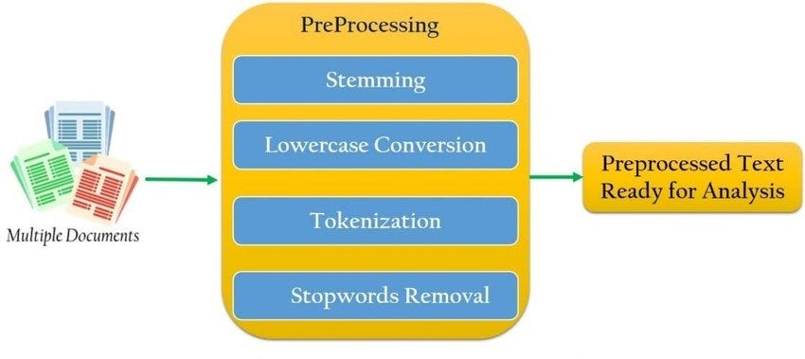

Picture 1: Preprocessing Flow

*Multinomial Naïve Bayes*

Naive Bayes machine learning model that is based on Bayes theorem. It is a model with a simple

logic behind it which performs well with sentiment analysis, spam filtering, and recommendation

systems. The logic behind this model lies in the Bayes formula.

P(c|x) =P(x|c) P(c) /P(x)

● The P(c|x) represents a probability of class c occurring if x occurred, in other words the

probability of class c for the feature x

● P(x|c) is the probability of the feature x given class c

● P(c) represents a probability of the class c

● P(x) represents the probability of the feature x occurring.

From the formula we see that this is a supervised machine learning model since we have to

calculate the probabilities of features and classes that are occurring in a given data set.

*Word Cloud*

In our project, we employed WordCloud to generate visualizations that highlight the most frequently occurring words in our Twitter dataset, excluding common stopwords. By filtering out these stopwords—common words like "and," "the," and "is"—we focused on presenting a more meaningful and contextually relevant representation of the text. This approach allowed us to visually emphasize the significant terms and themes within the Twitter data, offering a clearer and more insightful depiction of the prevalent words associated with the FIFA topic.

**Data and findings (results)**

In our study, we employed word cloud visualization, thorough text preprocessing, and VADER sentiment analysis coupled with a Multinomial Naive Bayes classifier. The word clouds highlighted key terms, while our meticulous text preprocessing refined the dataset. Leveraging VADER enhanced sentiment understanding, leading to improved classification accuracy. Together, these approaches provide a detailed exploration of patterns and sentiments within the Twitter data.

*Issues*

1. *Word Cloud Challenges:*

Initially struggled to find the right code for generating word clouds. Solved issues related to the wordcloud library installation by adding an exclamation mark before the pip command.

1. *Regex Expression Learning:*

Faced difficulties in constructing effective regex expressions. Overcame challenges by dedicating time to learn and understand regex through documentation.

1. *Sentiment Analyzer Implementation:*

Encountered challenges in working with sentiment analysis tools. Successfully addressed issues related to sentiment analyzer installation and configuration.

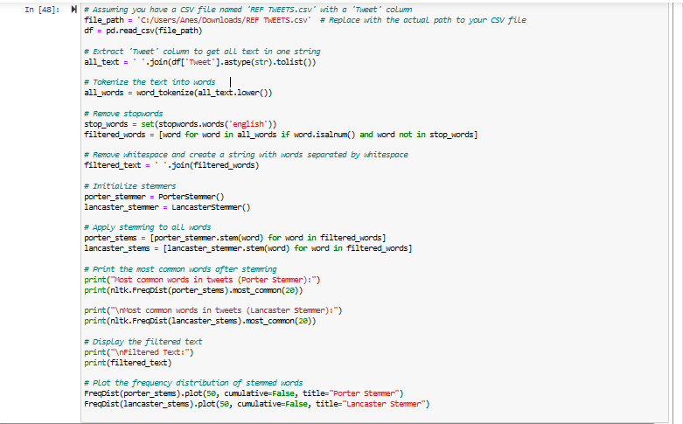

Picture 2: Example of Preprocessed Text

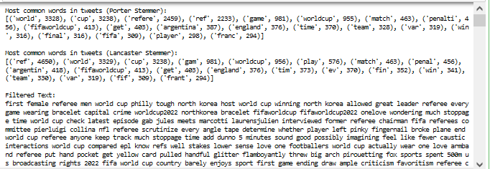

Picture 3: Output of the Preprocessed Text

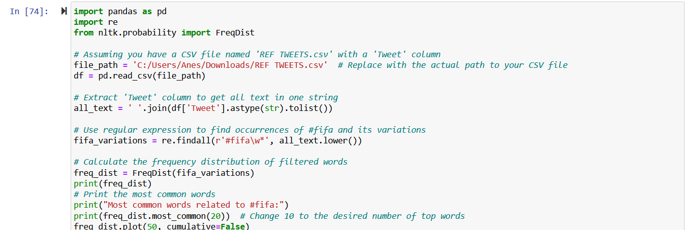

Picture 4: Example using Regex

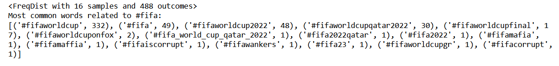

Picture 5: Output of the example above

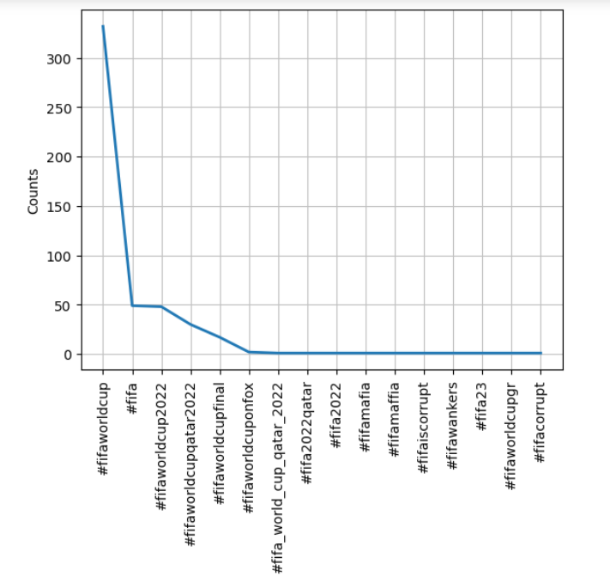

Picture 6: Its dispersion plot (graph)

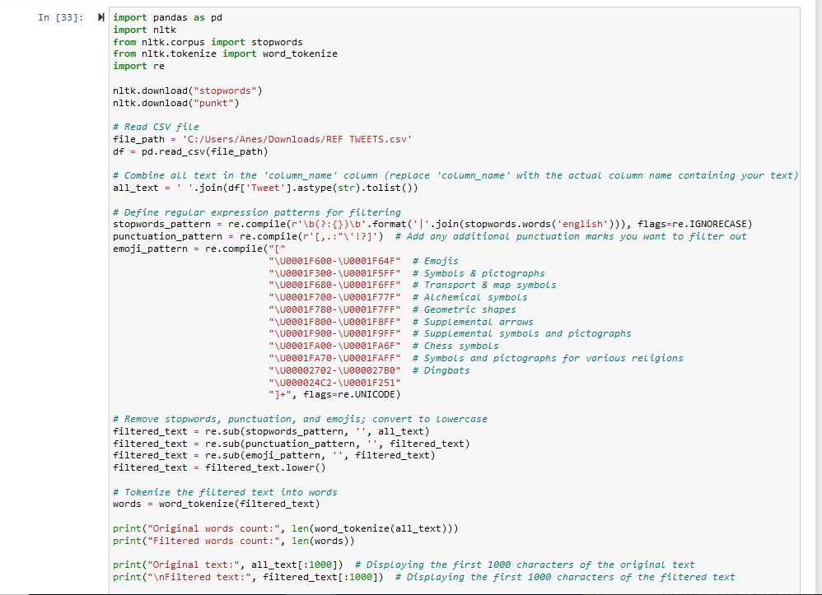

Picture 7: Another example of filtering text

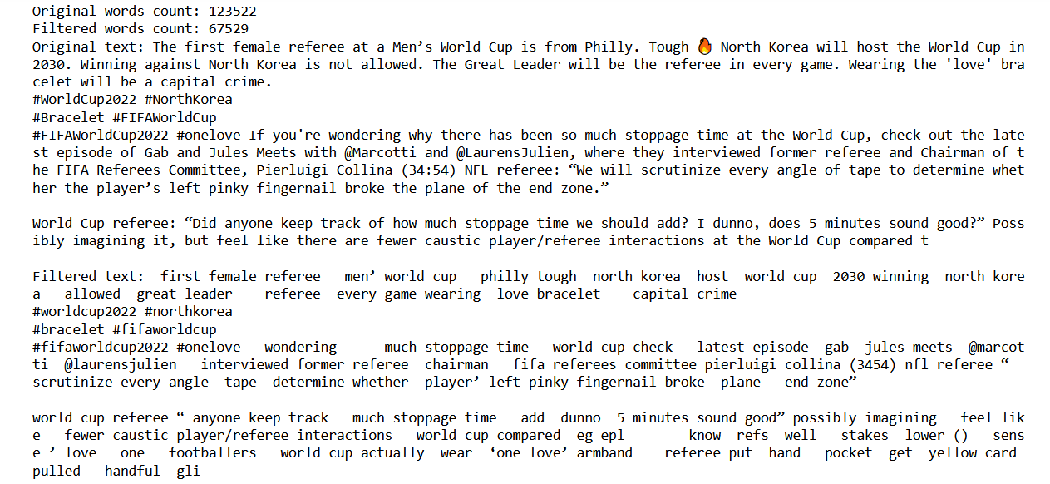

Picture 8: Its output

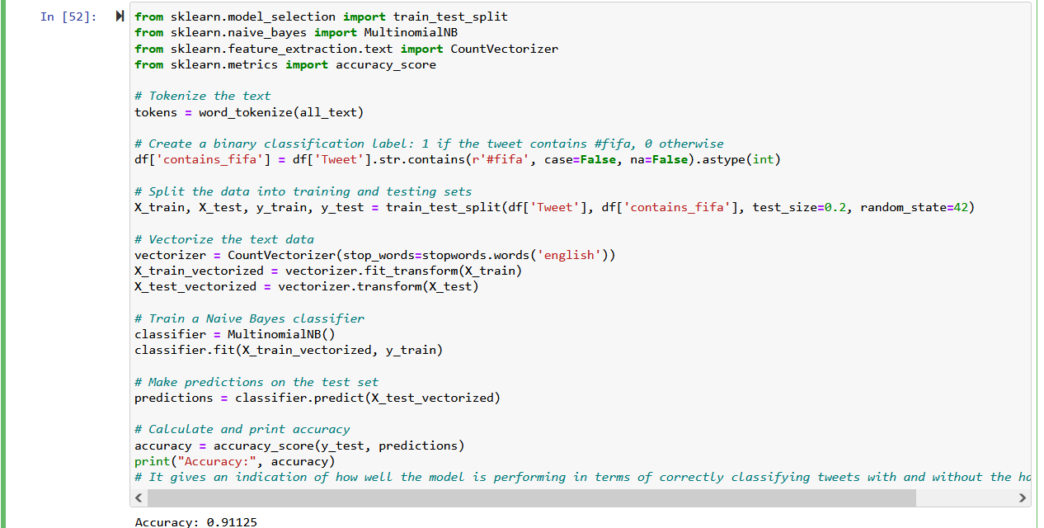

Picture 9: Accuracy using Vader‘s Sentiment Analysis

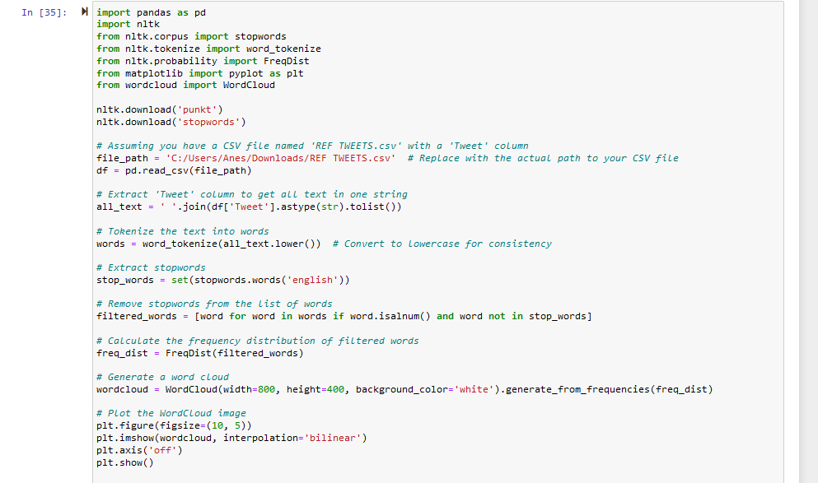

Picture 10: Most-common non-stopword words using WordCloud

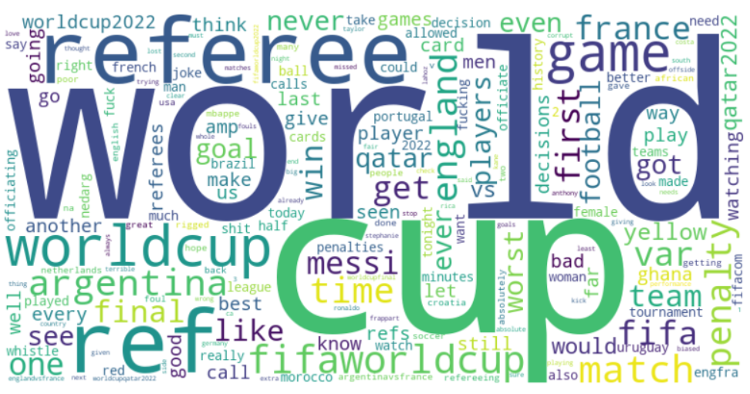

Picture 11: WordCloud Output

**Conclusion**

In conclusion, our research successfully employed advanced natural language processing techniques to analyze Twitter data. The combination of word cloud visualization, extensive text preprocessing, and sentiment analysis significantly contributed to a detailed understanding of sentiments expressed in tweets. The utilization of VADER sentiment analysis enhanced accuracy, enabling a comprehensive exploration of patterns and sentiments related to the chosen topic. Our findings provide valuable insights into sentiment dynamics on social media, underscoring the effectiveness of our approach in extracting meaningful information from large-scale text data.

## **REFERENCES**

[1] Natural Language Toolkit (NLTK) Documentation. [LINK](https://www.nltk.org/)

[2] Pang, B., & Lee, L. (2008). Opinion Mining and Sentiment Analysis. Foundations and Trends® in Information Retrieval. [LINK](https://www.cs.cornell.edu/home/llee/papers/sentiment.pdf)

[3] Loria, S. (2018). Challenges in Sentiment Analysis. ArXiv. [LINK](https://arxiv.org/abs/1809.07387)

[4] WordCloud Documentation. [LINK](https://github.com/amueller/word_cloud)

[5] General Inquirer. [LINK](http://www.wjh.harvard.edu/~inquirer)

[6] Kiritchenko, S., & Mohammad, S. M. (2018). Examining the extraction of opinion expressions under different types of figurative language. Language Resources and Evaluation. [LINK](https://link.springer.com/article/10.1007/s10579-017-9388-1)

[7] Devlin, J., et al. (2018). BERT: Pre-training of Deep Bidirectional Transformers for Language Understanding. [LINK](https://arxiv.org/abs/1810.04805)

[8] Liu, B. (2012). Sentiment Analysis and Opinion Mining. Synthesis Lectures on Human Language Technologies. [LINK](https://www.cs.uic.edu/~liub/FBS/SentimentAnalysis-and-OpinionMining.pdf)

[9] Caliskan, A., et al. (2017). Semantics derived automatically from language corpora contain human-like biases. Science. [LINK](https://science.sciencemag.org/content/356/6334/183)

[10] "Natural Language Processing in Python: Exploring Word Frequencies with NLTK" - Medium. [LINK](https://medium.com/@siglimumuni/natural-language-processing-in-python-exploring-word-frequencies-with-nltk-918f33c1e4c3)

[11] "Simple WordCloud using NLTK Library in Python" - NLPfy. [LINK](https://nlpfy.com/simple-wordcloud-using-nltk-library-in-python/)

[12] NLTK Regex Module Documentation. [LINK](https://www.nltk.org/api/nltk.chunk.regexp.html)

[13] ChatGPT [LINK](https://chat.openai.com/)

# **Useful softwares and extensions:**

* Google Scholar - Used for finding useful research papers. [LINK](https://scholar.google.com/)
* TextBlob - TextBlob is a simple and effective library for processing textual data. It provides a consistent API for diving into common natural language processing tasks, such as part-of-speech tagging, noun phrase extraction, sentiment analysis, classification, translation, and more. [LINK](https://github.com/sloria/TextBlob)
* WordCloud - WordCloud is a Python library for creating word clouds from text data. It allows you to visualize the most frequent words in a given text, with the size of each word indicating its frequency. WordCloud is often used for gaining insights into the most prominent terms within a corpus. [LINK](https://github.com/amueller/word_cloud)